RESOLUTION NO.__________

RE: CERTIFICATE OF APPROPRIATENESS UNDER THE
PROVISIONS OF THE ACT OF THE PENNSYLVANIA
LEGISLATURE 1961, JUNE 13, P.L. 282 (53
SECTION 8004) AND BETHLEHEM ORDINANCE NO.
3952 AS AMENDED.

WHEREAS, it is proposed to restore the façade on the building at 129 W 4th Street.

NOW, THEREFORE, BE IT RESOLVED by the Council of the City of Bethlehem that a Certificate of Appropriateness is hereby granted for the work.

Sponsored by: (s)

(s)

ADOPTED BY COUNCIL THIS DAY OF

(s)
President of Council

ATTEST:

(s)
City Clerk

HISTORIC CONSERVATION COMMISSION

CASE # 600– It is proposed to restore the façade on the building at 129 W 4th Street
OWNER/APPLICANT: Joe Hanna/ NYC Village Pizza

The Commission upon motion by Mr. Roeder seconded by Mr. Cornish adopted the proposal that City Council issue a Certificate of Appropriateness for the proposed work described herein:
- The proposal to restore the façade on the building at 129 W 4th Street was represented by Mustafa Okumus.

- The proposed work will be executed as shown in the drawings submitted with the following clarifications and modifications:
  - The leaded glass will be repaired not replaced.

  - The new black aluminum storefront framing will be installed on top of knee wall and not extend down to the foundation wall as shown in the drawings.

  - Grates, in metal, similar to the historic will be replicated and reinstalled in the storefront knee wall in the historic location.
  - The green 12” x 12” tile presented to the Commission will be used to clad the knee wall.

  - The entry floor green 3” x 3” tile will be repaired. The tile sample presented will be used in areas where replacement is necessary.
  - The apartment door at the eastern end of the storefront may be retained as a 6 panel steel door.

- At the rear of the property, facing west, a steel 6 panel door may be installed in one side of the existing 2 panel window due to low visibility. The second half of the window will remain glass.

- The motion to approve the proposal was unanimously approved.

CU: cu
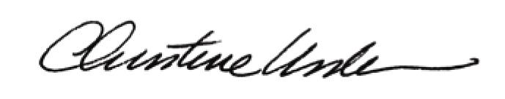

By:

Date of Meeting: November 21, 2016 Title: Historic Officer

